|  |
| --- |
|  |
| Toy Tank BATTLES |
| Mila Bromm - 40325069@live.napier.ac.uk |
| Alex Racey - 40312219@live.napier.ac.uk |

# Table of Contents

**Table of Contents** **1**

**Document History** **3**

**Overview and Vision Statement** **4**

**Inspirations** **4**

**Player Experience Goals** **5**

**Audience and Platform** **5**

Legal Analysis 5

**Gameplay** **6**

Overview 6

Player Mode 6

Screen Mockup(s) 6

Formal Elements 7

Players 7

Objectives 7

Procedures 7

Rules 7

Resources 7

Conflict 7

Boundaries 8

Outcome 8

Controls 8

Levels 8

Flowchart 9

Editor 9

Characters 9

Story 9

Game World 9

**Required Media List** **10**

User Interface Assets 10

Environment Assets 10

Character-based Assets 11

Animation Assets 11

Music Assets 12

Sound Effect Assets 12

**Technical Specification** **12**

Development Platform and Tools 12

Delivery Mechanism 13

Game Engine 13

User Interface Technical Requirements 13

Controls Technical Specification 13

Network Requirements 13

System Parameters 13

Flowchart 14

# Document History

|  |  |  |  |
| --- | --- | --- | --- |
| **Version** | **Date of Change** | **Notes on Changes** | **Contributor** |
| 1.0 | 25/02/2020 | * Began working on document (Overview and Vision Statement section) * Added contributor names to intro page | Alex Racey |
| 1.1 | 28/02/2020 | * Mostly added to the media section, first sprites that could be used and their description. | Mila Bromm |
| 1.2 | 29/02/2020 | * Added to the media section and technical spec. Sounds are added to media section, as well as a new sprite for a broken house | Mila Bromm |
| 1.3 | 01/03/2020 | * Finished Inspirations, Player Experience Goals, Audience and Platform, and Gameplay sections * Gameplay flowchart needs to be added to document | Alex Racey |
| 1.4 | 01/03/2020 | * Gameplay flowchart is now added to document * updated and added new mockups | Mila Bromm |

# Overview and Vision Statement

The primary vision for our proposed game is a single-player 2D top down shooter using tank versus tank combat. The game will be stylised using bright colours and will possess the stylised design of items from a children’s toy box.

# Inspirations

The first inspiration for our game came from the widely known 3D shooter World of Tanks, a game the competes teams of people with their own unique tanks on a battlefield to complete objectives, ranging from capturing checkpoints to destroying enemy vehicles. In addition the game allows users to choose from a range of tanks featuring their own abilities and limitations, it is our aim to replicate this for our game in a simpler form in terms of future game enhancements.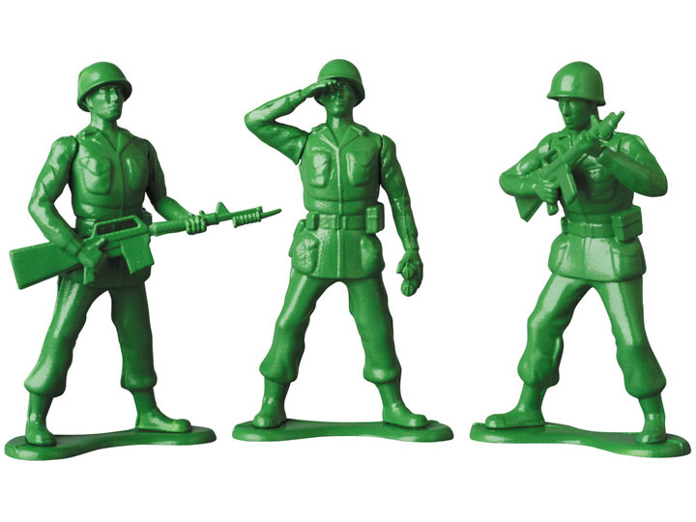

Another main inspiration for our game comes from the movie Toy Story; the film features characters and themes originating from a bright and colourful environment. The aim for our game is to create and use assets that recreate the environment of a toybox, using assets such as toy cars, teddy bears, building blocks, etc. This will create a less gritty environment for a tank shooter game compared to the appearance of more detailed and realistic game environments such as the one present in World of Tanks.

The final inspiration for our game involves utilising destructible game environments, that will allow the player tank to demolish select areas of the traversable level in order to open up new areas to move around that would have been previously inaccessible. By doing this, it is also an aim to have enemy player AI be able to detect these environment changes and to alter their movement path in an attempt to surround the player. This methodology is a main feature within the Battlefield series of games, where the Frostbite engine allows players to destroy environments to their choosing and allows for a varied number of firefights and encounters between players and enemies.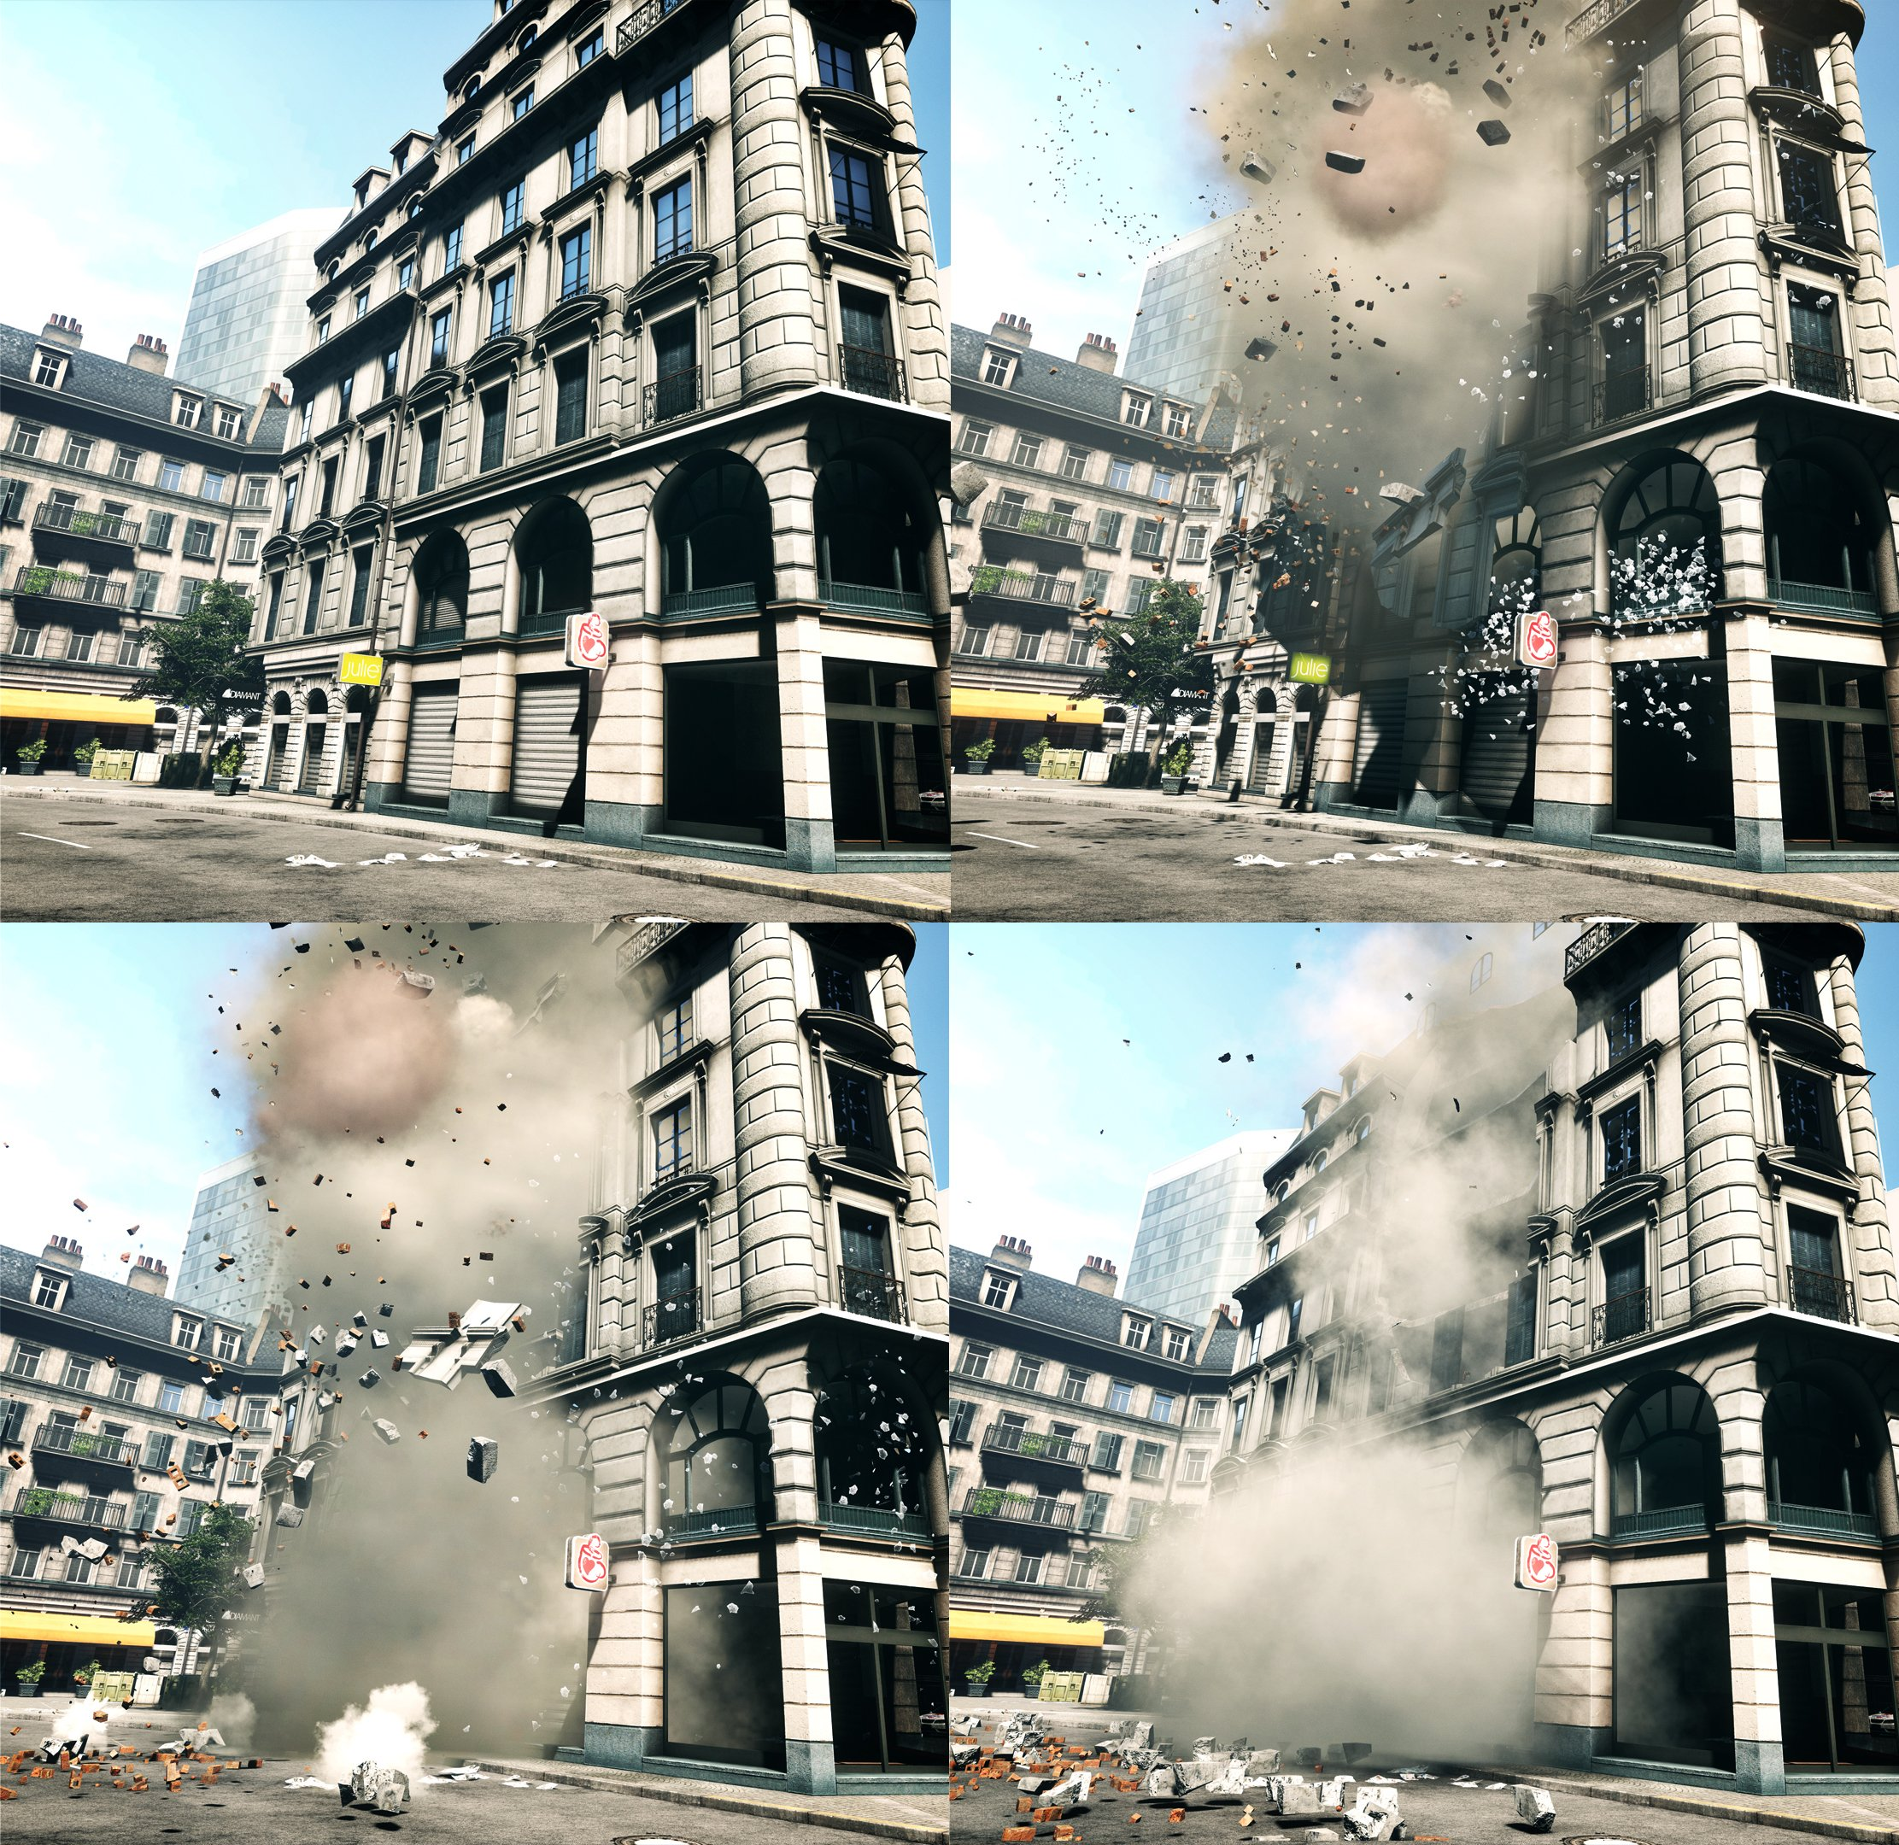

# Player Experience Goals

* Ability to destroy army of opponents, single-player versus the game interaction
* Ability to work against other players to complete an objective (if multiplayer were to be implemented)
* Players will experience element of stress as they will be working against a timer
* Conflict will be experienced between player and physical environment through contact with obstacles (maze walls) and NPC opponents

# Audience and Platform

The target audience for our game is children aged 7+, and the game will be produced for the PC platform, with the intention of creating a console version at a later date. The reason for this is that we wish the game to be widely available to play for a large audience, and it therefore should be able to run on a large number of devices. We aim to make the game controls simple enough to be used by a very young person, yet still maintain the entertainment that will allow an older audience to be able to still enjoy playing themselves.

As the game will not be very demanding in terms of specifications, the hardware requirements listed below are a rough prediction as to what will be needed in order to play the game to a reasonable standard (*Please note:* these are subject to change throughout development):

* Operating system - Windows 7 / 8 / 8.1
* RAM - 2GB or higher
* Processor - 2.4 GHz Intel Core 2 Duo or equivalent
* Graphics - NVIDIA GeForce 8600 GT or equivalent
* DirectX - Version 9.0 or higher
* Storage - 500MB available space
* Sound Card - DirectX 9 Compatible Audio
* Minimum Resolution: 1280 x 720

The main competitor to our game will be World of Tanks, however we believe the 2D nature and destructibility to our game environment will set apart our game from the competition and make it unique.

## Legal Analysis

* The game will be using content and sprite sheets created by outside sources, however when using it we will ensure the licence allows us to use them for a non commercial project.
* There are no financial implications as we are not paying anyone to produce content (such as sounds or assets) to be used for the game
* There are terms and conditions to consider are for the usage right for the Box2D game engine, as this is what will be used primarily to create the game

# Gameplay

## Overview

The core gameplay involves a single player-controlled tank attempting to eliminate a number of enemy tank players, while also avoiding elimination themselves. They will be able to traverse around a partially destructible environment that can be altered by the player’s actions in terms of what they decide to destroy. Finally, they will be timed to complete the level in a predetermined number of minutes, after which the game will end and the player will have failed the level.

### Player Mode

Single player, with aims to add a multiplayer co-op/versus mode in a future version.

## Screen Mockup(s)

**Menu:**

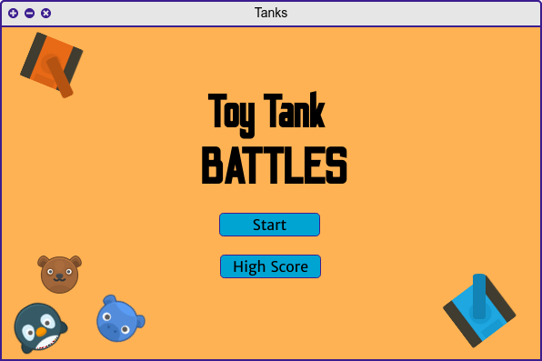

**Game Screen:**

## 

## Formal Elements

### Players

* Player Interaction pattern - Single player versus the game
* Player character - Small tank with one gun barrel (plan to add multiple tank variants in future versions
* Player tasks - Eliminate all enemy players, survive enemy attacks, complete level before set timer runs out

### Objectives

* Eliminate all enemy tanks in the quickest possible time, players compete for highscores
* Objective type - **destroy** (applies to enemy tanks and environment), **outwit** (destroy enemy tanks before they destroy the player tank

### Procedures

* Player can move their tank left, right, up and down using the WASD keys
* Using the tank to aim requires using the mouse to move the barrel of the tank in a clockwise or anti-clockwise rotation
* Tanks can fire bullets to destroy other tanks and to damage environmental assets, this action may create new traversable paths for the player to take

### Rules

* Certain elements in the environment are destructible, these will be indicated using their appearance. Other elements will not be destructible and will be indicated when the player shoots them
* The player will be timed to complete each level, if the timer depletes and enemy tanks remain, the player will have lost and the game will be over
* The player and enemies will have to abide by the maze boundaries of the level in terms of where they are able to move
* Player tanks have a certain amount of health, this will deplete periodically each time

### Resources

* A number of powerups will be spawned at random locations throughout the map, once picked up by the player they will give the player certain abilities. These include giving the player more health, speeding up player movement and improving the tank’s weaponry. These powerups will be made to look like different children’s toys, to keep with the theme of the game
* Player health is finite and needs to be conserved in order for the player to survive
* Player weapons fire bullets, a short amount of time needs to pass before they are able to fire a second bullet even though supply is infinite

### Conflict

* Players and enemy NPCs attempting to shoot and destroy one another is the main element of conflict present throughout the game
* Conflict between the player’s weapons and the game environment is caused when player tank bullets collide with destructible areas of the game world

### Boundaries

* Game is taking place in a tile map environment consisting of walls created by game assets, the user will not be able to move their player off the edge of the screen as this also represents the boundary of the game environment

### Outcome

* Winning state is declared when all enemy NPC tanks are destroyed within the time limit
* Game will end when winning state is declared, user will have to restart game or move to the next level in order to continue playing
* Player high scores gained from finishing levels will be added to a high score window

## Controls

* User interface requirements include buttons to start the game, exit the game, view a controls/options page, the ability to pause the game and to view a high score board
* Options should include giving the player the ability to change the game volume, to resize the game window to an alternative resolution, and to display a list of controls (custom mapping of controls is a feature that will be attempted to implement)
* Player obtains score from destroying tanks, a score multiplier will be implemented to increase the obtainable score depending on how many enemy NPCs can be destroyed in quick succession
* Winning conditions are met when player has successfully destroyed all enemy NPCs before the timer runs out

## Levels

Currently, one level will be the sole focus of implementation. This will be created manually using tile mapping, however it is the aim to have random generated levels. The benefit of this is that it will minimize the workload required to make a large number of levels, as well as it can be guaranteed that no two levels will be exactly the same. This benefits the overall playability as users will not become tired of playing the same levels constantly.

## Flowchart

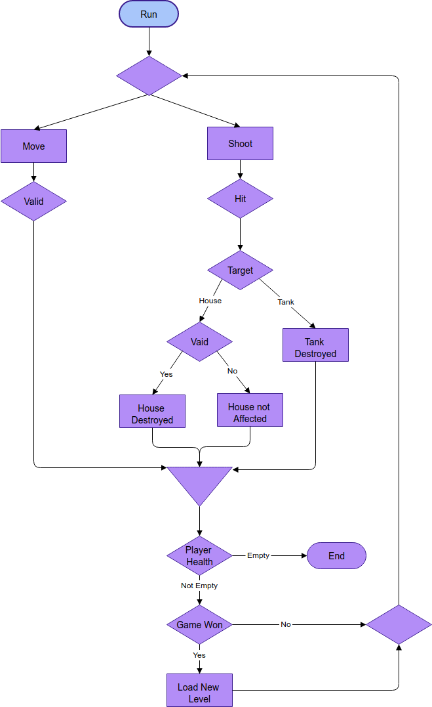

## Editor

Currently, there are no plans to develop an editor for the game.

## Characters

The tanks are small in size and have a cartoonist aesthetic, being square and stocky to increase their own likeness of coming from a child’s toy box. The player character is distinguishable by its differing colour from the enemy tanks; the player will be colored blue and the NPCs will be orange. These contrasting colours will make it easier for the user to distinguish which tank is the one that they are controlling.

## Story

In its current stage, the game does not have a story as we are aiming for an arcade style of playability. However a story may be added at a later date if it is deemed suited to ft in with the current state of the game.

## Game World

The game world is viewed from a 2D top down perspective, where the world is made up of a maze of buildings, some of which can be destroyed. The player tank will spawn at one side of the map, and enemy NPCs will spawn in random locations around the playable space. Any pickup resources will also spawn at a random spread across the game world, and will be randomised each time the level is replayed.

# Required Media List

## User Interface Assets

|  |  |
| --- | --- |
| Name | Description |
| Buttons | Menu buttons, to start the game and button to return to the menu. |
|  | Odibee Sans Font for game title |
| Other text fonts | Merriweather Sans, for other text used in the UI such as on button. |
| In game timer | timer to show the time spent in level. |
| Score value | Number representation of the player score |

## Environment Assets

|  |  |  |
| --- | --- | --- |
| Img | Name | Description |
|  | Houses | Used as maze walls. And restriction to player and enemy movement. |
|  | Broken House | Used to show player which houses he/she can destroy to open new pathways |
|  | Background | Pathment sprite  by:  <https://www.kenney.nl/assets/topdown-tanks> |
|  | Pickups | Power ups and item to heal or give player effects  Animal sprites by:  <https://www.kenney.nl/assets/animal-pack-redux> |
|  |  |  |

## Character-based Assets

Character based Assets taken from :

<https://www.kenney.nl/assets/topdown-tanks>

|  |  |  |
| --- | --- | --- |
| img | Name | Description |
|  | Player Tank | player tank consistent of movable turret and main tank body. |
|  | Enemy Tanks | enemy tank consistent of movable turret and main tank body. |
|  | player bullet | player bullet |
|  | enemy bullets | enemy bullet |

## Animation Assets

|  |  |  |
| --- | --- | --- |
| img | Name | Description |
|  | smoke | smoke for explosions or after shooting bullets?  <https://www.kenney.nl/assets/topdown-tanks> |
|  |  |  |

## Music Assets

|  |  |
| --- | --- |
| Name | Description |
| Background Music | In game background:  <https://freesound.org/people/GoodByte/sounds/442911/> |
| Menu Music | In menu music:  <https://freesound.org/people/martysonic/sounds/382054/> |
|  |  |

## Sound Effect Assets

|  |  |
| --- | --- |
| Name | Description |
| player shooting | Sound player tank should make:  <https://freesound.org/people/MATTIX/sounds/441373/> |
| enemy shooting | Sound enemy tank should make: <https://freesound.org/people/OGsoundFX/sounds/423109/> |
| tank destroyed | Tank destruction sound  <https://freesound.org/people/V-ktor/sounds/435414/> |
| house destroyed | House destruction sound  <https://freesound.org/people/samueleunimancer/sounds/384563/> |
| Game won | Sound for when player wins a level  <https://freesound.org/people/0EV/sounds/495005/>  <https://freesound.org/people/Kastenfrosch/sounds/113989/> |

# Technical Specification

## Development Platform and Tools

Developed using C++ and visual studio.

## Delivery Mechanism

Game executable exe files will be made available for delivery.

## Game Engine

Game engine will be written in C++ using the SFML graphics library.

Other libraries that we game engine might need will be written in C++ as well.

The engine should also include a library to load and handle the maze levels and a library to handle entity component management.

## User Interface Technical Requirements

Minimum Resolution: 1280 x 720 .

## Controls Technical Specification

Implemented controls should be mouse and keyboard, other means of controls might be implemented if there should be enough time or in a future version.

## Network Requirements

The aim is to build a single player game that will not need internet connection to play for now. In a future version of this project network connection could be used for more than one player to join a game.

## System Parameters

Max players for this version will be one against an army of computer controlled tanks. In a future version or if there is more this could be changed to allow two players play on the same keyboard with a second mouse.

## Flowchart

**Menu navigation**